

Requirement & Design Specification

**PawHouse**

**Version: 1.0**

– Can Tho, January 2025 –

# Member

| # | Full name | Student ID | Account |
| --- | --- | --- | --- |
| 1 | Phan Thành Hưng | CE180265 | HungPT |
| 2 | Võ Chánh Huy | CE181002 | HuyVC |
| 3 | Nguyễn Huỳnh Chấn Hưng | CE180150 | HungNHC |
| 4 | Trương Phú Hưng | CE180618 | HungTP |
| 5 | Trần Hữu Tín | CE180262 | TinTH |
| 6 | Huỳnh Hoàng Huy | CE181847 | HuyHH |

# Revision History

# 

*A - Added M - Modified D - Deleted

| **Version** | **Date** | **A,M,D** | **Assignee** | **Change Description** |
| --- | --- | --- | --- | --- |
| 0.1 | 12/01/2025 | A | HuyHH | Write base for SRS Document |
| 0.1 | 13/01/2025 | D | HungPT | Draw ERD and write Entities description |
| 0.1 | 13/01/2025 | D | HungNHC | Write SRS - II.4 - Customer Management Screen |
| 0.1 | 13/01/2025 | D | TinTH | Write SRS - II.1 - Login Screen |
| 0.1 | 13/01/2025 | D | HuyVC | Write SRS - II.2 Forgot Password Screen |
| 0.1 | 13/01/2025 | D | HungTP | Write SRS - II.5 - Product Management Screen |
| 0.1 | 13/01/2025 | D | HungPT | Write SRS - II.6 - Order Management Screen |
| 0.1 | 13/01/2025 | D | TinTH | Write SRS - II.2 DashBoard Screen |
| 0.2 | 15/01/2025 | A | HungPT | Draw ERD and write Entities description |
| 0.2 | 15/01/2025 | A | HuyHH | Write Entities description |
| 0.2 | 15/01/2025 | A | HungNHC | Write SRS - II.4 - Customer Management Screen |
| 0.2 | 15/01/2025 | A | TinTH | Write SRS - II.1 - Manage Customer |
| 0.2 | 15/01/2025 | A | HuyVC | Write SRS - II.2 - Manage Pet |
| 0.2 | 15/01/2025 | A | HungTP | Write SRS - II.3 - Manage Medicine |
| 0.2 | 15/01/2025 | A | HungPT | Write SRS - II.4 - Manage Service |
| 0.2 | 15/01/2025 | A | TinTH | Write SRS - II.5 - Manage Order |
| 0.2 | 16/01/2025 | A | HungPT | Write SRS - II.6 - Manage Product Comment |
| 0.2 | 16/01/2025 | A | HungPT | Write SRS - II.7 - Create Account |
| 0.1 | 17/01/2025 | D | HungNHC | Draw ScreenFlow, Screen Descriptions, Screen Authorization |
| 0.2 | 18/01/2025 | A | HungNHC | Update Draw ScreenFlow, Screen Descriptions, Screen Authorization |

# 

# 

# Contents

**Member 2**

**Revision History 2**

**Contents 4**

I. Overview 6

1. User Requirements 6

1.1 Actors 6

1.2 Use Cases 7

2. Overall Functionalities 14

2.1 Screens Flow 14

2.2 Screen Descriptions 18

2.3 Screen Authorization 20

2.4 Non-UI Functions: 23

3. System High Level Design 24

3.1 ERD 24

3.2. Database Design 25

3.3. Code Packages 29

**II. Requirement Specifications 31**

1. Manage customer 31

1.1 UC-E-1-1: View all customers 31

1.2 UC-E-1-2: View detail a customer 32

1.3 UC-E-1-3: Update Customer 34

2. Manage pet 37

2.1 UC-E-2-1: View all pet 37

2.2 UC-E-2-2: Add new pet 38

2.3 UC-E-2-3: View detail a pet 40

2.4 UC-E-2-4: Update pet 42

3. Manage Product 44

3.1 UC-E-3-1: View all Product 44

3.2 UC-E-3-2: Add new Product 45

3.3 UC-E-3-3: View detail Product 47

3.4 UC-E-3-4: Update Product 49

4. Manage service 51

4.1 UC-E-4-1: View All Services 51

4.2 UC-E-4-2: Add new service 52

4.3 UC-E-4-3: View detail service 55

4.4 UC-E-4-4: Update Service 57

4.5 UC-E-4-5: Booking Service Appointment 59

4.6 UC-E-4-6: View Details Service Appointment 61

4.7 UC-E-4-7: Update Appointment 63

4.8 UC-E-4-8: Cancel Appointment 65

5. Manage order 66

5.1 UC-E-5-1: Add New Order 66

5.2 UC-E-5-2: View All Orders 68

5.3 UC-E-5-3: View Order Details 70

5.4 UC-E-5-4: Update Order 71

5.5 UC-E-5-5: Cancel Order 73

6. Manage Product Comment 75

6.1 UC-E-6-1: Add Comment 75

6.2 UC-E-6-2: Delete Comment 76

6.3 UC-E-6-3: Update Comment 78

7. Account 80

7.1 UC-E-7-1: Sign Up 80

7.2 UC-E-7-2: Login 82

7.3 UC-E-7-3: Sign Out 83

7.4 UC-E-7-4: Add new role 85

# I. Overview

## 1. User Requirements

### 1.1 Actors

*Welcome to* ***PawHouse****, the ultimate website for pet care and a vibrant community for animal lovers! PawHouse is not just a platform for finding valuable information about pet care but also a shared home where people come together to exchange experiences and express their love for pets*

| **#** | **Actor** | **Description** |
| --- | --- | --- |
| 1 | Admin | The administrator of the system who has full access to all features and functionalities. Responsible for managing the website's operations, such as user accounts, product listings, orders, and reports. |
| 2 | Guest | Unregistered users who can browse the website without logging in. Guests can view basic product information, explore content about pet care, and initiate the registration process to become a customer. |
| 3 | Customer | Registered users who have logged into the system. Customers can manage their profiles, place orders, track order history, update payment information, and provide feedback. They are the primary target audience for the platform's services |
| 4 | Staff | Employees who assist in managing daily operations. Staff members can handle tasks such as managing orders, updating product details, and generating reports. They have limited access to administrative features and focus on operational tasks. |
| 5 | Doctor | Veterinary doctors who provide medical services for pets. They can manage appointments, view and update patient (pet) records, write medical reports, prescribe medicines, and communicate with pet owners. |

### 

### 

### 1.2 Use Cases

#### a. Use case diagram

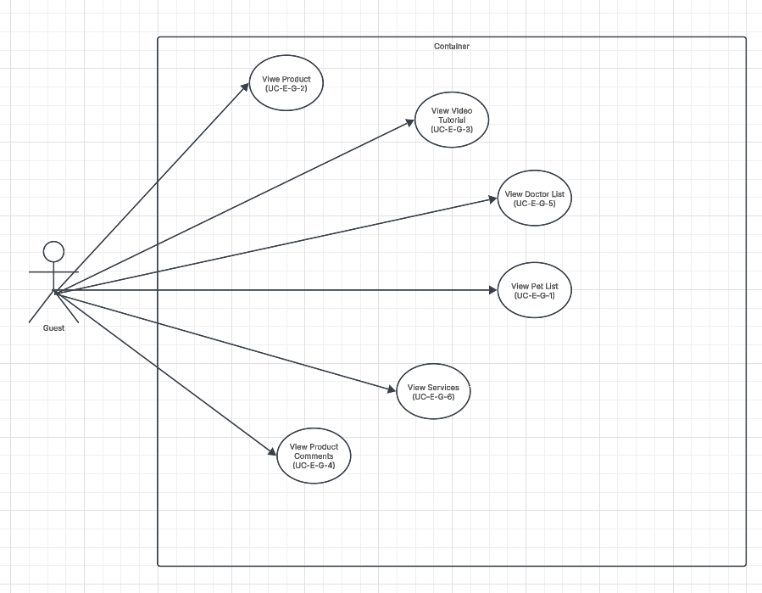

Figure 1.2.1: Use Case Guest

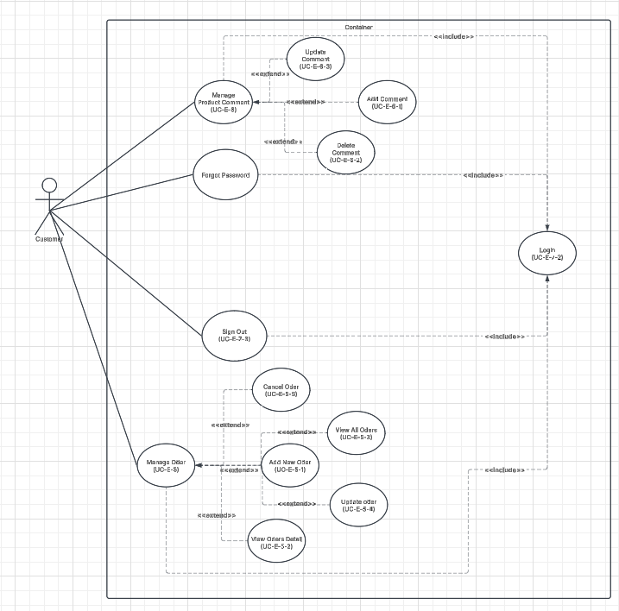

Figure 1.2.2: Use Case Customer

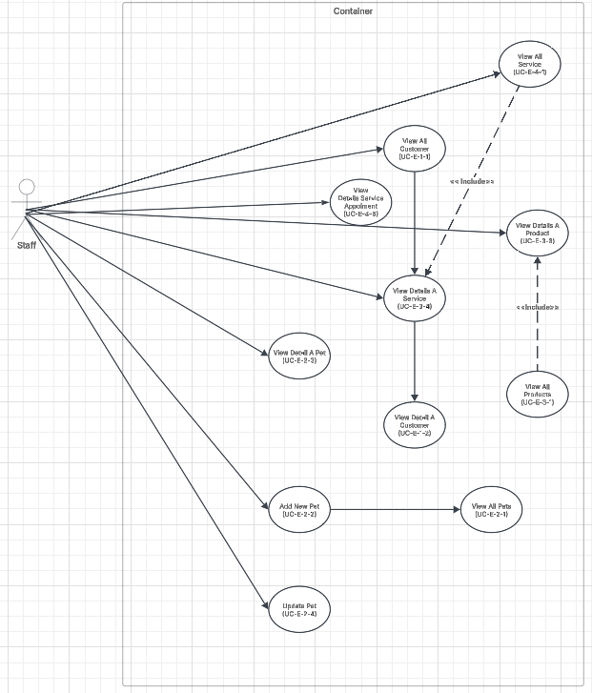

Figure 1.2.3: Use Case Staff

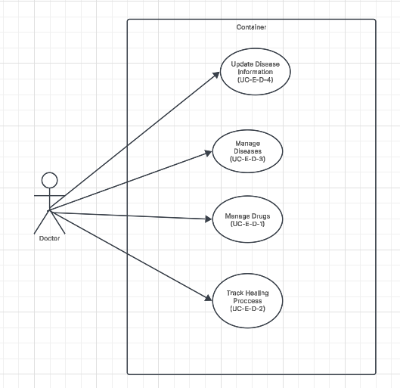

Figure 1.2.4: Use Case Doctor

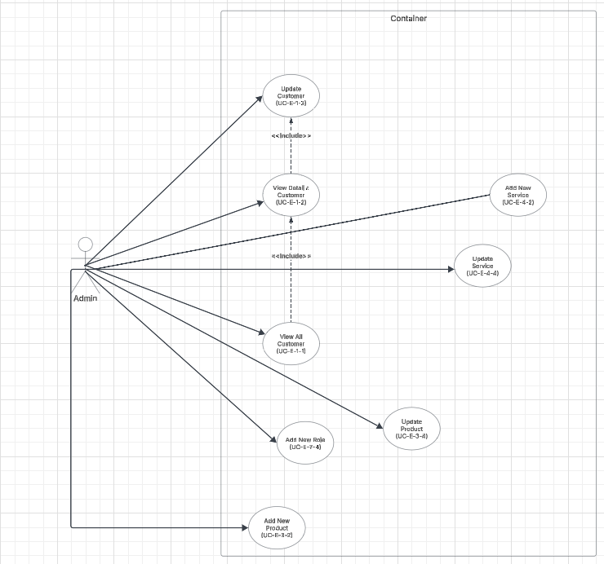

Figure 1.2.5: Use Case Admin

#### b. Descriptions

*This part describes the use cases, you can follow the table form as below*

| **ID** | **Feature** | **Use Case** | **Use Case Description** |
| --- | --- | --- | --- |
| 01 | Login | Login | Allow registered account to log in to the website by email and password, can login with google |
| 02 | Register | Register | Allow guests to register a new account to log in to the website |
| 03 | View Profile | View Profile | Allow guests can view their profile with basic information |
| 04 | Forgot Password | Forget password | Allow Customer can get new password if they forgot |
| 06 | Logout | Logout | Allow Customer, Admin, Staff and Doctor can log-out Website |
| 07 | Update Profile | Update profile | Allow Customer, Admin, Staff and Doctor to update their personal information in their profile. |
| 08 | Change Password | Change password | Allow Customer, Admin, Staff and Doctor can change Password |
| 09 | Make Payment by Cash | Make Payment | Customers pay when receiving goods |
| 10 | Make Payment by Card | Make Payment | Customers pay by bank card |
| 11 | View Service History | View Service History | Allow Customer can view service History |
| 12 | View Order Product | Add to Cart | Allow Customer view Order Product |
| 13 | Edit product in cart | Manage Cart | Allow customer can edit product in cart |
| 14 | View Cart | Manage Cart | Allow customer can view Product they choose |
| 15 | Delete Product in Cart | Manage Cart | Allow customer can delete product in Cart |
| 16 | View Product | View Product | Allow Guest,Customer, Admin, Staff and Doctor can view Product in website |
| 17 | View Doctor List | View Doctor List | Guest,Customer, Admin, Staff and Doctor can view a list of doctors and their specialties for consulting or booking purposes |
| 18 | View Pet List | View Pet List | Guest,Customer, Admin, Staff and DoctorCan view a list of pets available for adoption, purchase, or other purposes. |
| 19 | View Video Tutorial | View Video Tutorial | | Guest,Customer, Admin, Staff and Doctor can view tutorials or educational videos related to pet care. | | --- | |
| 20 | View Product Comment | View Product comment | Guest,Customer, Admin, Staff and Doctor can browse comments to read posts and discussions about pet care or services. |
| 21 | Health Tracking | Health Tracking | Allows Doctors to monitor and manage the health status of their pets effectively. This functionality enables users to: |
| 22 | Drug Management | Drug Management | Allows Doctor can Management Drugs |
| 23 | Disease management | Disease management | Monitor and record pet illnesses and treatments. |
| 24 | Disease Update | Disease Update | Deliver the latest updates and information about diseases affecting pets. |
| 25 | Create new account | Manage Staff | Allow admin can create new account |
| 25 | Edit Account | Manage Staff | Allow admin can edit information account |
| 27 | Delete account | Manage Staff | Allow admin can delete account in system |
| 28 | View log staff | View log staff | Allow admin can view log staff |
| 29 | View by day | View order report | Allow Staff can view order reports by day |
| 30 | View by month | View order report | Allow Staff can view order reports by month |
| 31 | View by year | View order report | Allow Staff can view order reports by year |
| 32 | Create new product | Manage product | Allow Staff can create new products |
| 33 | Delete product | Manage product | Allow Staff can delete products |
| 34 | Edit product | Manage product | Allow Staff to Edit product( price, info, number product…) |
| 35 | Create new pet | Manage Pet | Allow Staff can add new pet in store.  Allow Customer to add their pets.. |
| 36 | Delete pet | Manage Pet | Allow Staff can delete pet in store  Allow Customer to delete their pets. |
| 37 | Edit pet | Manage Pet | Allow Staff can edit information pet in store.  Allow Customer to customize their pets. |
| 38 | Create new product | Manage order report | Allow Staff can create new order report |
| 39 | Delete product | Manage order report | Allow Staff can delete order report |
| 40 | Edit product | Manage order report | Allow Staff can Edit order report |
| 41 | Manage Doctor | Manage Doctor | Allow Staff can management doctors in website |
| 42 | View Comment Product | Product Comment | Allow Staff, Admin, Guest and Customer can read comment |
| 43 | Add Comment | Product Comment | Allow Staff, Admin, Guest and Customer can add comment |
| 44 | Edit Comment | Product Comment | Allow Staff, Admin, Guest and Customer can edit comment |
| 45 | Delete Comment | Product Comment | Allow Staff, Admin, Guest and Customer can delete comment |
| 46 | Admin’s delete comment | Manage Comment | Allow Admin can delete comment of Customer or Doctor |
| 47 | View all services | Manage Service | Allow Customer, Guest view list services |
| 48 | Add new services | Manage Service | Allow Admin, Staff and Doctor add new services |
| 49 | View detail services | Manage Service | Allow Admin, Staff and Doctor view detail services |
| 50 | Update services | Manage Service | Allow Admin, Staff and Doctor update services |
| 51 | Update services | Manage Service | Allow Admin, Staff and Doctor update services |
| 52 | Booking service appointment | Manage Service | Allow Customer booking appointment |
| 53 | View service appointment | Manage Service | Allow Customer and Doctor view appointment |
| 54 | Update service appointment | Manage Service | Allow Customer and Doctor update appointment |
| 55 | Cancel service appointment | Manage Service | Allow Customer and Doctor cancel appointment |
| 56 | View all Customer | Manage customer | Allow admin view all list customer |
| 57 | View detail Customer | Manage customer | Allow admin view detail a customer |
| 58 | Update Customer | Manage customer | Allow admin update a customer |
| 59 | Add new role | Account | Allow admin add new role for page |

## 2. Overall Functionalities

### 2.1 Screens Flow

**Guest**

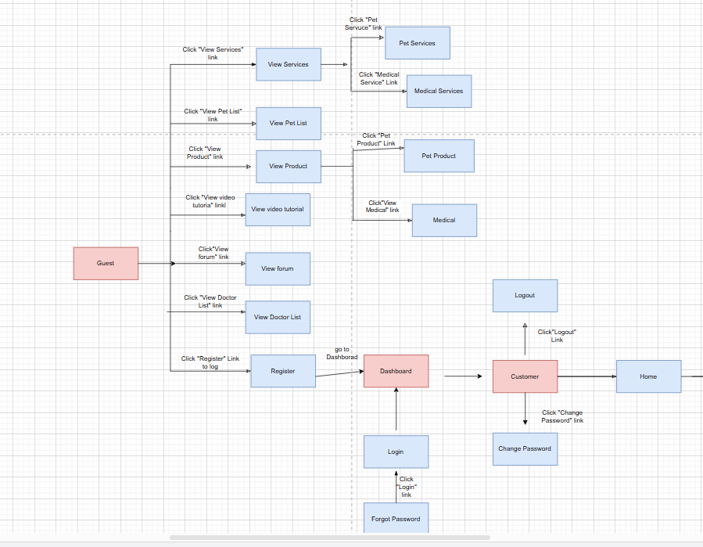

**Figure 2.1.1 The Guest method**

**Customer**

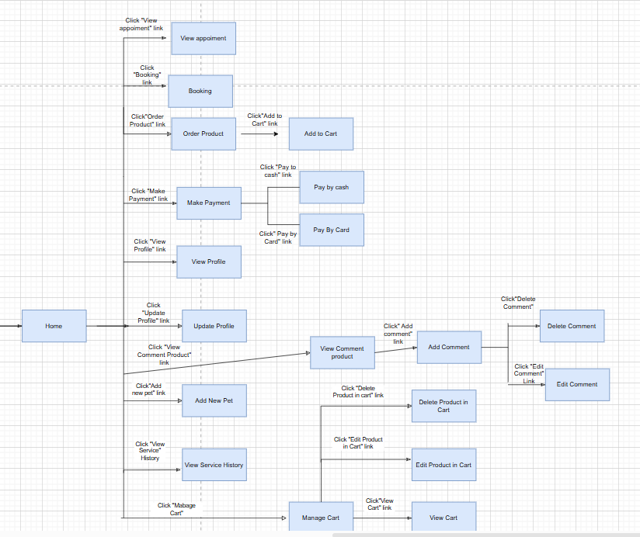

**Figure 2.1.2 The Customer method**

***Staff***

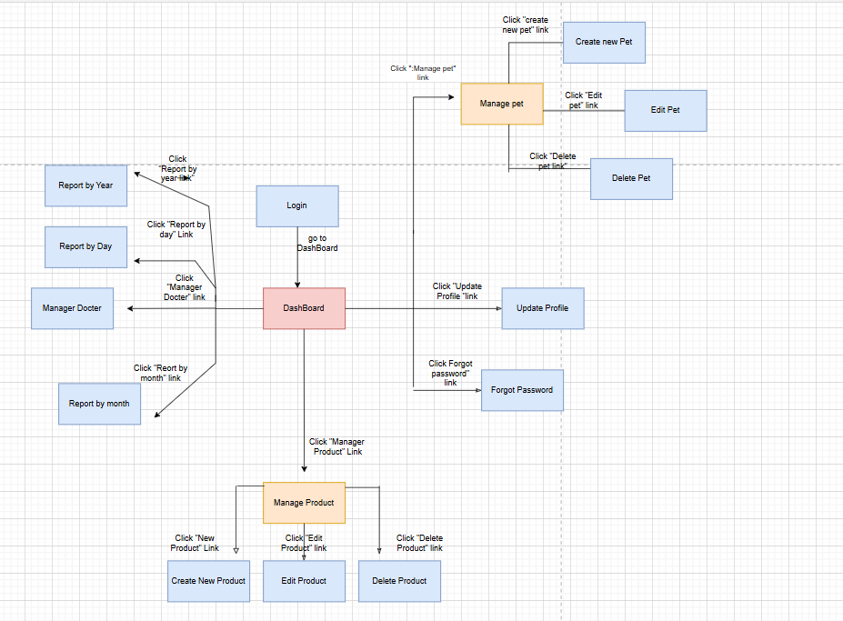

Figure 2.1.3 The Staff method

**Doctor**

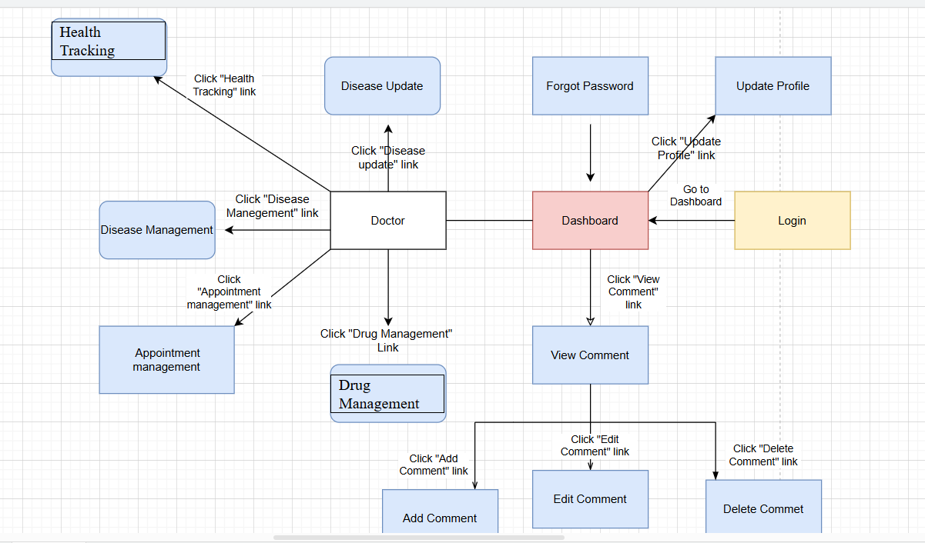

Figure 2.1.4 The doctor method

**Admin**

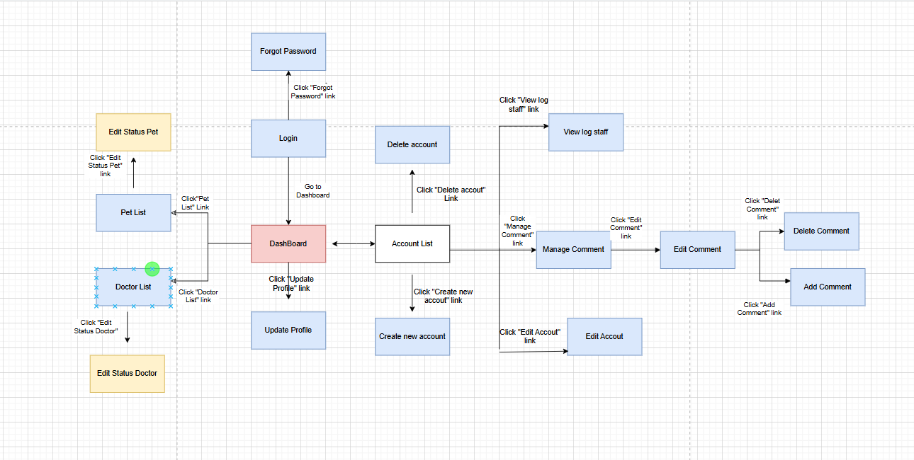

Figure 2.1.5 The Admin method

### 2.2 Screen Descriptions

| **#** | **Feature** | **Screen** | **Description** |
| --- | --- | --- | --- |
| 1 | Login | Login | Customer,Admin,Doctor and Staff login to web |
| 2 | Login with Google | Login With Google | Customer,Admin,Doctor and Staff login to Web with Google |
| 3 | Register | Register | Guest |
| 4 | View Profile | View Profile | Customer,Admin,Doctor and Staff View their information |
| 5 | Interact with Product Comment | Interact with Forum | Customer,Admin,Doctor and Staff can interact with product comment |
| 6 | Update Profile | Update Profile | Customer,Admin,Doctor and Staff can update their information |
| 7 | Logout | Logout | Customer,Admin,Doctor and Staff can log out their account |
| 8 | Forgot Password | Forgot Password | Customer,Doctor, Staff and Admin can get new password if they not remember |
| 9 | Change Password | Change Password | Customer,Admin,Doctor and Staff can change their password |
| 10 | View service history | View Service History | Customer,Doctor and Staff can view service history their use |
| 11 | Pay by cash | Make payment | Customer can pay product by cash |
| 12 | Pay by card | Make payment | Customer can pay product by card |
| 13 | Order product | Order product | Customer can order product |
| 14 | Add to cart | Add to cart | Customer can add to cart |
| 15 | Edit product in cart | Edit product in cart | Customer can edit product in cart |
| 16 | View Cart | View Cart | Customer can view cart |
| 17 | Delete Product in cart | Delete Product in cart | Customer can delete product in cart |
| 18 | View Pet List | View Pet List | Guest,Customer,Admin,Doctor and Staff can view pet list |
| 19 | View Product | View Product | Guest,Customer,Admin,Doctor and Staff can view product |
| 20 | View video tutorial | View video tutorial | Guest,Customer,Admin,Doctor and Staff can view video tutorial |
| 21 | View Product Comment | View Product Comment | Guest,Customer,Admin,Doctor and Staff can view product comment |
| 22 | View Doctor List | View Doctor List | Guest,Customer,Admin,Doctor and Staff can view Doctor list |
| 23 | Edit account | Account Management | Admin can edit account in system |
| 24 | Delete account | Account Management | Admin can delete account in system |
| 25 | View log staff | View log staff | Admin can view log staff in system |
| 26 | Create new account | Create new account | Admin can create new account in system |
| 27 | Drug management | Drug management | Doctor can management drug |
| 28 | Healing Tracking | Healing Tracking | Doctor can view healing tracking |
| 29 | Disease management | Disease management | Doctor can management disease |
| 30 | Disease Update | Disease Update | Doctor can update disease |
| 31 | Report by day | Report by day | Staff can view report by day |
| 32 | Report by month | Report by month | Staff can view report by month |
| 33 | Report by year | Report by year | Staff can view report by year |
| 34 | Manage Doctor | Manage Doctor | Staff can manage doctor in system |
| 35 | Create new product | Manage product | Staff, Admin can create new product in store |
| 36 | Edit product | Manage product | Staff, Admin can edit product in store |
| 37 | Pet Services | View Services | Guest,Customer,Admin,Doctor and Staff can view pet services |
| 38 | Medical Services | View Services | Guest,Customer,Admin,Doctor and Staff can view Medical Service |
| 39 | Pet Product | View Product | Guest,Customer,Admin,Doctor and Staff can view Pet Product |
| 40 | Medical Product | View Product | Guest, Customer,Admin,Doctor and Staff can view Medical product |
| 41 | Delete product | Manage product | Staff, Admin can delete product |
| 42 | Create new pet | Manage pet | Staff, Admin can create new pet |
| 43 | Edit pet | Manage pet | Staff, Admin can edit pet |
| 44 | Delete pet | Manage pet | Staff, Admin can Delete pet |
| 45 | Add comment | Product Comment | Customer, Staff, Admin, Doctor can add comments |
| 46 | Edit comment | Product Comment | Customer, Staff, Admin, Doctor can edit comments |
| 47 | Delete comment | Product Comment | Customer, Staff, Admin, Doctor can delete comments |
| 48 | Manage comment | Manage Comment | Admin, Staff can delete comments of Customers, Doctor, Staff |
| 49 | View History Medical | Manage Medical | Staff and Doctor manage medicals. |
| 50 | Confirm Order | Manage Order | Staff, Admin can confirm order of customer |
| 51 | List Order | Manage Order | Staff, Admin can view list order of customer |

### 2.3 Screen Authorization

| **Screen/Function** | **Role-Guest** | **Role**  **Customer** | **Role**  **Admin** | **Role-Staff** | **Role**  **Doctor** |
| --- | --- | --- | --- | --- | --- |
| **Home** | X | X | X | X | X |
| **Login** |  | X | X | X | X |
| **Register** | X |  |  |  |  |
| **Forget Password** |  | X | X | X | X |
| **Update Profile** |  | X | X | X | X |
| **Change Password** |  | X | X | X | X |
| **View history order** |  | X |  |  |  |
| **View history medical** |  |  | X |  | X |
| **Logout** |  | X | X | X | X |
| **View Cart** |  | X |  |  |  |
| **Payment information** |  | X |  |  |  |
| **Payment** |  | X |  |  |  |
| **Dashboard** |  | X | X | X | X |
| **Add Order Product** |  | X |  |  |  |
| **Add to Cart** |  | X |  |  |  |
| **Edit Product in Cart** |  | X |  |  |  |
| **Delete Product in Cart** |  | X |  |  |  |
| **Confirm Order** |  |  | X | X |  |
| **View List Order** |  |  | X | X |  |
| **Add Product** |  |  | X | X |  |
| **Edit Product** |  |  | X | X |  |
| **Delete Product** |  |  | X | X |  |
| **Add Pet** |  |  | X | X |  |
| **Edit Pet** |  |  | X | X |  |
| **Delete Pet** |  |  | X | X |  |
| **View Pet Product** | X | X | X | X | X |
| **View Medical Product** | X | X | X | X | X |
| **View Pet Services** | X | X | X | X | X |
| **View Medical Services** | X | X | X | X | X |
| **View Pet List** | X | X | X | X | X |
| **View Video Tutorial** | X | X | X | X | X |
| **View Product** | X | X | X | X | X |
| **View Product Comment** | X | X | X | X | X |
| **View Doctor List** | X | X | X | X | X |
| **Manage Appointments** |  |  |  |  | X |
| **View Patient Records** |  |  |  |  | X |
| **Write Medical Reports** |  |  |  |  | X |
| **Prescribe Medicine** |  |  |  |  | X |
| **Communicate with Patients** |  |  |  |  | X |
| **Report by year** |  |  |  | X |  |
| **Report by month** |  |  |  | X |  |
| **Report by day** |  |  |  | X |  |
| **Manage Doctor** |  |  |  | X |  |
| **Account Management** |  |  | X |  |  |
| **Add Staff** |  |  | X |  |  |
| **Edit Staff** |  |  | X |  |  |
| **View Log Staff** |  |  | X |  |  |
| **Add Comment Product** |  | X | X | X | X |
| **Delete Comment** |  | X | X | X | X |
| **Edit Comment** |  | X | X | X | X |
| **Manage Comment** |  |  | X | X |  |

### 2.4 Non-UI Functions:

Non-functional requirements ensure that the PawHouse system not only functions correctly but also has good performance, security, and scalability.

| **#** | **Feature** | **Function** | **Description** |
| --- | --- | --- | --- |
| 1 | Performance | Response Time Optimization | - The homepage must load in under 3 seconds on a standard internet connection (50 Mbps). |
| 2 | Security | Data Encryption | - Users must enter a valid username/email and password to log in.  - Passwords must be hashed before storage (e.g., bcrypt). |
| 3 | Data Protection | Input Validation | Validate user inputs to prevent SQL Injection (use PreparedStatement instead of raw SQL queries). |
| 4 | Access Control | Role-Based Access | - Restrict access to certain pages based on user roles (e.g., Admin, Customer, Staff). |
| 5 | Database Response | Efficient Queries | - CRUD operations (Create, Read, Update, Delete) should complete in under 2 seconds. |
| 6 | Friendly UI | Responsive Design | - The website must work on PC (using Bootstrap or CSS Flexbox). |

### 

### 

## 3. System High Level Design

### 3.1 ERD

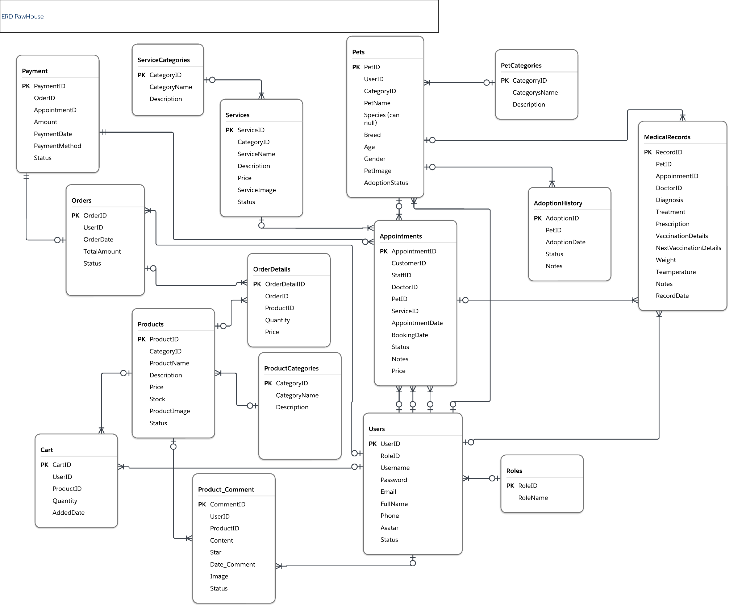

### 3.2. Database Design

#### Database Schema

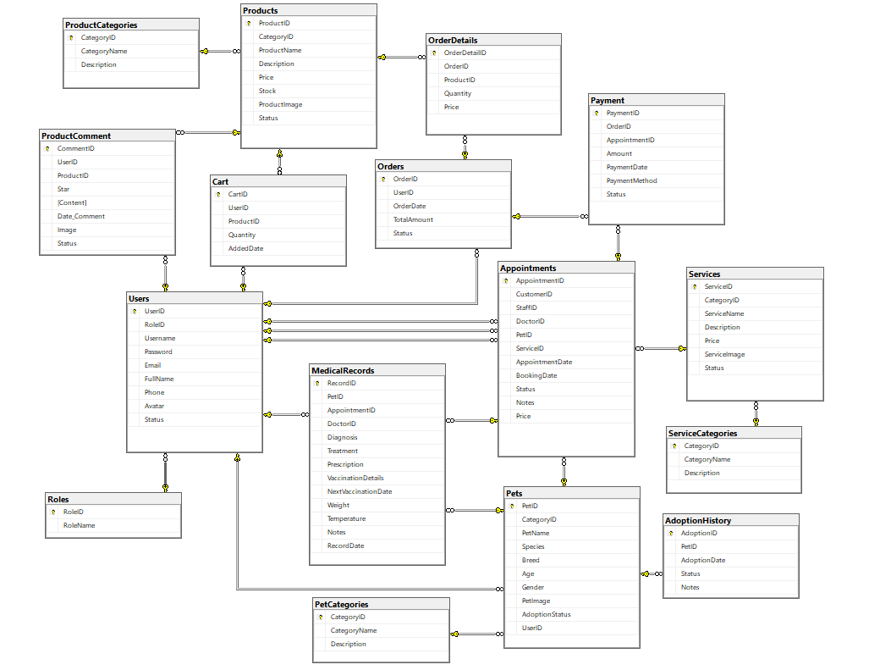

#### Table Descriptions

| **No** | **Table** | **Description** |
| --- | --- | --- |
| **01** | **Users** | **Users Information** - Primary keys: UserID (int) - Foreign keys: RoleID (int) - Unique: Username: (nvarchar(50)) - Password: nvarchar(100) - Email: nvarchar(100) - FullName: nvarchar(100) - Phone: nvarchar(20) - Avatar: nvarchar(255) - Status: bit |
| **02** | **AdoptionHistory** | **AdoptionHistory Information**  - Primary keys: AdoptionID (int) - Foreign keys: PetID (int) - AdoptionDate: datetime - Status: nvarchar(20) - Notes: nvarchar(500) |
| **03** | **Appointments** | **Appointments Information** - Primary keys: AppointmentID (int) - Foreign keys: CustomerID (int) - Foreign keys: StaffID (int) - Foreign keys: DoctorID (int)  - Foreign keys: ServiceID (int)  - AppointmentDate: datetime - BookingDate: datetime - Price: decimal(18,2)  - Status: nvarchar(20) - Notes: nvarchar(500 ) |
| **04** | **Cart** | **Cart Information** - Primary keys: CartID (int) - Foreign keys: UserID (int) - Foreign keys: ProductID (int) - Quantity: int - AddedDate: datetime |
| **05** | **OrderDetails** | **OrderDetails Information** - Primary keys: OrderDetailID (int) - Foreign keys: OrderID (int) - Foreign keys: ProductID (int) - Quantity: int - Price: decimal(18,2) |
| **06** | **Orders** | **Orders Information** - Primary keys: OrderID (int) - Foreign keys: UserID (int) - OrderDate: datetime - TotalAmount:decimal(18,2) - Status: nvarchar(50) |
| **07** | **Pets** | **Pets Information** - Primary keys: PetID (int)  - Foreign keys: CategoryID (int)  - Foreign keys: UserID (int) - PetName: nvarchar(100)  - Species: nvarchar(50)  - Breed: nvarchar(50)  - Age: int  - Gender: nvarchar(10)  - PetImage: nvarchar(255)  - AdoptionStatus: nvarchar(50) |
| **08** | **Products** | **Products Information** - Primary keys: ProductID (int) - Foreign keys: CategoryID (int) - ProductName: nvarchar(100) - Description: nvarchar(255) - Price: decimal(18,2) - Stock: int - ProductImage: nvarchar(255)  - Status: bit |
| **09** | **Roles** | **Roles Information** - Primary keys: RoleID (int) - RoleName: nvarchar(50) |
| **10** | **Services** | **Services Information** - Primary keys: ServiceID (int)  - Foreign keys: CategoryID (int)  - ServiceName: nvarchar(100)  - Description: nvarchar(255)  - Price: decimal(18,2)  - ServiceImage: nvarchar(255)  - Status: bit |
| **11** | **Service Categories** | **ServiceCategories Information** - Primary keys: CategoryID (int) - CategoryName: nvarchar(100) - Description: nvarchar(255) |
| **12** | **Payment** | **Payment Information** - Primary keys: PaymentID (int) - Foreign keys: OrderID (int) - Foreign keys: AppointmentID (int) - Amount: decimal(18,2) - PaymentDate: datetime - PaymentMethod: nvarchar(50) - Status: nvarchar(50) |
| **13** | **Pet Categories** | **PetCategories Information** - Primary keys: CategoryID (int) - CategoryName: nvarchar(100) - Description: nvarchar(255) |
| **14** | **Product Categories** | **ProductCategories Information**  - Primary keys: CategoryID (int) - CategoryName: nvarchar(100) - Description: nvarchar(255) |
| **15** | **Medical Records** | **Medical Records Information**  - Primary keys: RecordID (int)  **-** Foreign keys: PetID (int)  **-** Foreign keys: AppointmentID (int)  **-** Foreign keys: DoctorID (int)  **-** Diagnosis: nvarchar(500)  - Treatment: nvarchar(500)  - Prescription: nvarchar(500)  - VaccinationDetails: nvarchar(500)  - NextVaccinationDate datetime  - Weight; decimal(5, 2)  - Temperature; decimal(4, 1)  - Notes; nvarchar(1000)  - RecordDate: datetime |
| **16** | **Product Comment** | **- Primary keys: CommentID** (int)  **-** Foreign keys: UserID (int)  **-** Foreign keys: ProductID (int)  - Star (int)  - Content: nvarchar(500)  - Date_Comment: datetime  - Image: nvarchar(255)  - Status: bit |

# 

# 

# 

# 

### 

### 

### 

### 

### 

### 

### 3.3. Code Packages

#### Package Descriptions

| **No** | **Package** | **Description** |
| --- | --- | --- |
| 1 | Member_authority | Manage user permissions, including authentication, authorization, and access control. |
| 2 | Registration | Handles user registration, including email validation and storage of registration information. |
| 3 | AuthenticationService.Api | Contains controllers and filters to handle authentication and authorization. |
| 4 | AuthenticationService.Application | Contains services, DTOs, and business logic related to authentication. |
| 5 | AuthenticationService.Infrastructure | Manage database connections and store authentication data. |

#### Package Diagram

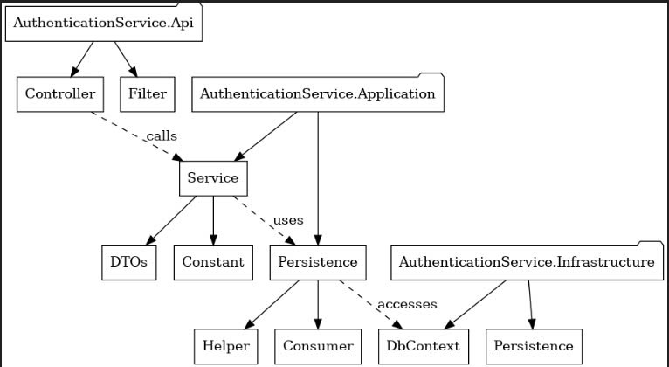

# 

# **II. Requirement Specifications**

## **1. Manage customer**

### **1.1 UC-E-1-1: View all customers**

#### **a. Functionalities**

| UC ID and Name: | UC-E-1-1: View all customers | | |
| --- | --- | --- | --- |
| Created By: | Nguyễn Huỳnh Chấn Hưng | Date Created: | 02/02/2025 |
| Primary Actor: | Admin | Secondary Actors: | staff |
| Trigger: | An employee wants to view all customers and click the `Khách hàng` button. | | |
| Description: | A function that allows employees to view all customers in the system | | |
| Preconditions: | PRE-1. Employees must be logged into the .  PRE-2. There are already customers in the database. | | |
| Postconditions: | POST-1. Data Displayed: All customer information is correctly displayed. | | |
| Normal Flow: | **NF-1. View all customers**  1. Click `Khách hàng` button | | |
| Alternative Flows: | **N/A** | | |
| Exceptions: | **E-1. Database connection failure**  1. The PawHouse generates an exception indicating the database connection failure.  2. The Employee is notified of the issue and prompted to check network connectivity. | | |
| Priority: | High (Must Have) | | |
| Frequency of Use: | Approximately 3 employees, each one average of 20 usage per day. | | |
| Business Rules: | BR1,BR2. | | |
| Other Information: | **N/A** | | |
| Assumptions: | 1.The system has a stable internet connection.  2.All employees are properly trained to use the "Khách hàng" functionality. | | |

#### **b. Business Rules**

| **ID** | **Business Rule** | **Business Rule Description** |
| --- | --- | --- |
| BR1 | Only employees | Only authorized employees (Admin/Staff) can access the "Khách hàng" view. |
| BR2 | Tabular format | Data must be retrieved from the system's customer database and displayed in a tabular format. |

### **1.2 UC-E-1-2: View detail a customer**

#### **a. Functionalities**

| UC ID and Name: | UC-E-1-2: View detail a customer | | |
| --- | --- | --- | --- |
| Created By: | Nguyễn Huỳnh Chấn Hưng | Date Created: | 01/02/2025 |
| Primary Actor: | Admin | Secondary Actors: | staff |
| Trigger: | An admin or staff wants to view detailed information about a specific customer and clicks the “View details” button. | | |
| Description: | A function that allows admin or staff to view detailed information of a selected customer stored in the system. | | |
| Preconditions: | PRE-1. Admin or staff must be logged into the system.  PRE-2. Customer data must exist in the database | | |
| Postconditions: | POST-1. The system displays all detailed information of the selected customer. | | |
| Normal Flow: | NF-1. View Customer Details  1. Admin or staff selects a customer from the customer list.  2. Admin or staff clicks the “View details” button  3. The system retrieves and displays the detailed information of the selected customer. | | |
| Alternative Flows: | 1. If the selected customer does not exist in the database, the system displays an error message.  2. Admin or staff is prompted to check the customer list again. | | |
| Exceptions: | **E-1. Database connection failure**  1. The system generates an exception indicating the database connection failure.  2. Admin or staff is notified of the issue and prompted to check network connectivity.  **E-2. Data Retrieval Error**  1. If there is an issue retrieving customer data, the system displays an error message.  2. Admin or staff is advised to contact IT support. | | |
| Priority: | High (Medium) | | |
| Frequency of Use: | Approximately 3 employees, each one averaging 30 views per day. | | |
| Business Rules: | BR3,BR4,BR6. | | |
| Other Information: | **N/A** | | |
| Assumptions: | Admin or staff has the necessary permissions to access the customer management module. | | |

#### b. Business rules

#### 

| **ID** | **Business Rule** | **Business Rule Description** |
| --- | --- | --- |
| BR3 | Mandatory | Customer name and contact details are mandatory. |
| BR4 | Duplicate customer | Duplicate customer entries are not allowed. |
| BR6 | Only be viewed | Customer details can only be viewed, not edited, on this screen. |

### **1.3 UC-E-1-3: Update Customer**

#### **a. Functionalities**

| UC ID and Name: | UC-E-1-3: Update customer | | |
| --- | --- | --- | --- |
| Created By: | Nguyễn Huỳnh Chấn Hưng | Date Created: | 25/02/2025 |
| Primary Actor: | Staff | Secondary Actors: | Customer |
| Trigger: | An admin or staff wants to update the information of an existing customer by selecting the customer and clicking the”Edit”button. | | |
| Description: | A function that allows admin or staff to update existing customer information in the system. | | |
| Preconditions: | PRE-1. Admin or staff must be logged into the system.  PRE-2. The customer to be updated must exist in the database. | | |
| Postconditions: | POST-1. The updated customer information is saved in the database. | | |
| Normal Flow: | **NF-1. Update Customer Information**  1. Admin or staff selects a customer from the customer list.  2. Admin or staff clicks the ”Edit”button  3. The system displays the customer's current information.  4. Admin or staff modifies the necessary details.  5. Admin or staff clicks “Save” to store the updated information.  6. The system validates the input and confirms the updates. | | |
| Alternative Flows: | **A-1. Cancel Update**  1. Customer or staff clicks the”Cancel” button instead of Save.  2. No changes are made to the customer's information, and the system returns to the customer list.  **A-2. Missing Information**  1. If required fields are left empty, the system prompts the user to fill in all mandatory details.  2. Customer or staff corrects the input and resubmits.. | | |
| Exceptions: | **E-1. Database connection failure**  1. The system generates an exception indicating the database connection failure.  2. Admin or staff is notified of the issue and prompted to check network connectivity.  E-2. Data Conflict Error  1. The system detects a conflict (e.g., duplicate email or phone number).  2. Admin or staff is notified and prompted to resolve the conflict. | | |
| Priority: | High (Must ) | | |
| Frequency of Use: | Approximately 3 employees, each one averaging 10 updates per day. | | |
| Business Rules: | BR3,BR4,BR7,BR8,BR9. | | |
| Other Information: | **N/A** | | |
| Assumptions: | Admin or staff has the necessary permissions to access the customer management module. | | |

#### b. Business rules

#### 

| **ID** | **Business Rule** | **Business Rule Description** |
| --- | --- | --- |
| BR7 | Valid and accurate | Customers must provide valid and accurate information. |
| BR8 | Validation | Certain fields (e.g., email, phone number) must meet validation criteria. |
| BR9 | Logged | Updates should be logged for security and audit purposes. |

## **2. Manage pet**

### **2.1 UC-E-2-1: View all pet**

#### **a. Functionalities**

| UC ID and Name: | UC-E-2-2: View All Pets | | |
| --- | --- | --- | --- |
| Created By: | Võ Chánh Huy | Date Created: | 18/02/2025 |
| Primary Actor: | Admin | Secondary Actors: | staff |
| Trigger: | An admin or staff wants to view a list of all pets in the system. | | |
| Description: | A function that allows admin or staff to view a list of all pets stored in the system. | | |
| Preconditions: | PRE-1. Admin or staff must be logged into the system. | | |
| Postconditions: | POST-1. The system displays the list of all pets. | | |
| Normal Flow: | **NF-1. View All Pets**  1. Admin or staff clicks the”Pets” or “View All Pet” button.  2. The system retrieves and displays a list of all pets, including key details such as name, species, and owner. | | |
| Alternative Flows: | If there are no pets in the database, the system displays a message indicating no records are available. | | |
| Exceptions: | **E-1. Database connection failure**  1. The system generates an exception indicating the database connection failure.  2. Admin or staff is notified of the issue and prompted to check network connectivity. | | |
| Priority: | High (Must Have) | | |
| Frequency of Use: | Approximately 10 views per day. | | |
| Business Rules: | BR10,BR11. | | |
| Other Information: | **N/A** | | |
| Assumptions: | Pet data in the database is accurate and up-to-date. | | |

#### **b. Business Rules**

#### 

| **ID** | **Business Rule** | **Business Rule Description** |
| --- | --- | --- |
| BR10 | Only authorized users | Only authorized users can access the list. |
| BR11 | Sorted | The list should be sorted and filterable (e.g., by species, owner)... |

### **2.2 UC-E-2-2: Add new pet**

#### **a. Functionalities**

| UC ID and Name: | UC-E-2-1: Add New Pet | | |
| --- | --- | --- | --- |
| Created By: | Võ Chánh Huy | Date Created: | 27/02/2025 |
| Primary Actor: | Admin | Secondary Actors: | staff |
| Trigger: | An admin or staff member wants to add a new pet's information into the system. | | |
| Description: | A function that allows admin or staff to input and save new pet details into the system. | | |
| Preconditions: | PRE-1. Admin or staff must be logged into the system | | |
| Postconditions: | POST-1. The new pet's information is saved in the database. | | |
| Normal Flow: | **NF-1. Add New Pet**  1. Admin or staff clicks the “Add pet” button.  2. Admin or staff inputs all required pet details (e.g., name, species, breed, owner information).  3. Admin or staff clicks “Save” to store the information.  4. The system validates the input and confirms the pet has been successfully added. | | |
| Alternative Flows: | **A-1. Missing Information**  1. If required fields are not filled, the system displays an error message.  2. Admin or staff corrects the input and resubmits. | | |
| Exceptions: | **E-1. Database connection failure**  1. The system generates an exception indicating the database connection failure.  2. Admin or staff is notified of the issue and prompted to check network connectivity. | | |
| Priority: | High (Must Have) | | |
| Frequency of Use: | Approximately 5 additions per day. | | |
| Business Rules: | BR12,BR13. | | |
| Other Information: | **N/A** | | |
| Assumptions: | Admin or staff has accurate knowledge of the pet's information. | | |

#### b. Business rules

#### 

| **ID** | **Business Rule** | **Business Rule Description** |
| --- | --- | --- |
| BR12 | Fields all | All mandatory fields must be completed before saving. |
| BR13 | Manage | Admin or staff must have permissions to manage pet records. |

### **2.3 UC-E-2-3: View detail a pet**

#### **a. Functionalities**

| UC ID and Name: | UC-E-2-3: View Detail a Pet | | |
| --- | --- | --- | --- |
| Created By: | Võ Chánh Huy | Date Created: | 28/02/2025 |
| Primary Actor: | Admin | Secondary Actors: | staff |
| Trigger: | An admin or staff wants to view detailed information about a specific pet by selecting it from the list. | | |
| Description: | A function that allows admin or staff to view detailed information of a selected pet. | | |
| Preconditions: | PRE-1. Admin or staff must be logged into the system.  PRE-2. Pet data must exist in the database. | | |
| Postconditions: | POST-1. The system displays all detailed information of the selected pet. | | |
| Normal Flow: | **NF-1. View Pet Details**  1. Admin or staff selects a pet from the list.  2. Admin or staff clicks the”View details” button.  3. The system retrieves and displays the pet's detailed information. | | |
| Alternative Flows: | If the selected pet does not exist in the database, the system displays an error message. | | |
| Exceptions: | **E-1. Database connection failure**  1. The system generates an exception indicating the database connection failure.  2. Admin or staff is notified of the issue and prompted to check network connectivity. | | |
| Priority: | High (Must Have) | | |
| Frequency of Use: | Approximately 8 views per day. | | |
| Business Rules: | BR3,BR4,BR14. | | |
| Other Information: | **N/A** | | |
| Assumptions: | Pet data in the database is accurate and up-to-date. | | |

#### b. Business rules

#### 

| **ID** | **Business Rule** | **Business Rule Description** |
| --- | --- | --- |
| BR14 | read-only on | Pet details should be read-only on this screen. |

### **2.4 UC-E-2-4: Update pet**

#### **a. Functionalities**

| UC ID and Name: | UC-E-2-4: Update Pet | | |
| --- | --- | --- | --- |
| Created By: | Võ Chánh Huy | Date Created: | 27/02/2025 |
| Primary Actor: | Admin | Secondary Actors: | staff |
| Trigger: | An admin or staff wants to update the information of an existing pet by selecting it and clicking the”Edit”button. | | |
| Description: | A function that allows admin or staff to update existing pet information in the system. | | |
| Preconditions: | PRE-1. Admin or staff must be logged into the system.  PRE-2. The pet to be updated must exist in the database. | | |
| Postconditions: | POST-1. The updated pet information is saved in the database. | | |
| Normal Flow: | **NF-1. Update Customer Information**  1. Admin or staff selects a pet from the pet list.  2. Admin or staff clicks the ”Edit”button  3. The system displays the pet's current information.  4. Admin or staff modifies the necessary details.  5. Admin or staff clicks “Save” to store the updated information.  6. The system validates the input and confirms the updates. | | |
| Alternative Flows: | **A-1. Cancel Update**  1. Admin or staff clicks the “Cancel” button.  2. No changes are made to the pet's information, and the system returns to the pet list.  **A-2. Missing Information**  1. If required fields are left empty, the system prompts the user to complete the fields.  2. Admin or staff corrects the input and resubmits. | | |
| Exceptions: | **E-1. Database connection failure**  1. The system generates an exception indicating the database connection failure.  2. Admin or staff is notified of the issue and prompted to check network connectivity. | | |
| Priority: | High (Must Have) | | |
| Frequency of Use: | Approximately 5 updates per day. | | |
| Business Rules: | BR9,BR12. | | |
| Other Information: | **N/A** | | |
| Assumptions: | Admin or staff has accurate knowledge of the updated pet information. | | |

#### b. Business rules

None

## **3. Manage Product**

### **3.1 UC-E-3-1: View all Product**

#### **a. Functionalities**

| UC ID and Name: | UC-E-3-1: View All Product | | |
| --- | --- | --- | --- |
| Created By: | Võ Chánh Huy | Date Created: | 01/03/2025 |
| Primary Actor: | Customer | Secondary Actors: | staff |
| Trigger: | Customer navigates to the "Products" page. | | |
| Description: | Displays a list of all available products in the store, including their name, price, and key details. | | |
| Preconditions: | PRE-1. The product database must be available.  PRE-2. Products must be active (available for sale). | | |
| Postconditions: | POST-1. The product list is displayed. | | |
| Normal Flow: | **NF-1. Display Products**  1. Customer navigates to the "Products" page.  2. The system retrieves product data from the database.  3. Displays product list with details:   a. Product name   b. Price   c. Image   d. Brief description.  4. Customer can apply filters (e.g., categories, price range) or sort options. | | |
| Alternative Flows: | If no products are available, the system displays: "No products available at this time." | | |
| Exceptions: | If the system fails to retrieve the data, it logs the error and displays: "Unable to load services. Please try again later." | | |
| Priority: | High (Must Have) | | |
| Frequency of Use: | Frequent | | |
| Business Rules: | BR11 | | |
| Other Information: | N/A | | |
| Assumptions: | Customers will browse to find products to purchase. | | |

#### **b. Business Rules**

None

#### 

### **3.2 UC-E-3-2: Add new Product**

#### **a. Functionalities**

| UC ID and Name: | UC-E-3-2: Add New Product | | |
| --- | --- | --- | --- |
| Created By: | Võ Chánh Huy | Date Created: | 25/02/2025 |
| Primary Actor: | Admin | Secondary Actors: | staff |
| Trigger: | Admin clicks "Add New Product" in the admin panel. | | |
| Description: | Enables administrators to add new products to the store's inventory. | | |
| Preconditions: | PRE-1. Admin must be logged in.  PRE-2. Product information must be complete. | | |
| Postconditions: | POST-1. The new product is added to the database.  POST-2. The product is visible in the customer-facing store. | | |
| Normal Flow: | **NF-1. Add Product Process**  1. Admin navigates to the admin panel.  2. Clicks Add New Product.  3. Fills out the product form:   a. Name   b. Description   c. Price   d. Category   e. Quantity in stock   f. Uploads images.  4. Clicks Save.  5. System validates input and saves product to the database.  6. A confirmation message is displayed: "Product added successfully." | | |
| Alternative Flows: | **A-1. Missing Information**  1.If required fields are incomplete, the system prompts: "Please complete all required fields." | | |
| Exceptions: | **E-1. System Error**  1. If the product cannot be added, the system logs the error and notifies the admin. | | |
| Priority: | High (Must Have) | | |
| Frequency of Use: | Occasional | | |
| Business Rules: | BR16 | | |
| Other Information: | **N/A** | | |
| Assumptions: | Admins have permissions to add products. | | |

#### b. Business rules

#### 

| **ID** | **Business Rule** | **Business Rule Description** |
| --- | --- | --- |
| BR16 | Unique | Service names must be unique. |

### 

### **3.3 UC-E-3-3: View detail Product**

#### **a. Functionalities**

| UC ID and Name: | UC-E-3-3: View Detail Product | | |
| --- | --- | --- | --- |
| Created By: | Võ Chánh Huy | Date Created: | 17/02/2025 |
| Primary Actor: | Customer | Secondary Actors: | staff |
| Trigger: | Customer clicks on a product from the product list. | | |
| Description: | Displays detailed information about a selected product, including description, specifications, and availability. | | |
| Preconditions: | PRE-1. The product must exist in the database.  PRE-2. The customer must access the product via the product list. | | |
| Postconditions: | POST-1. The detailed information about the product is displayed. | | |
| Normal Flow: | **NF-1. View Product Details**  1. Customer clicks on a product.  2. System retrieves product details from the database.  3. Displays the following information:   a. Full description   b. Price   c. Specifications   d. Availability   e. Customer reviews.  4. Customer can choose to add the product to their cart or navigate back. | | |
| Alternative Flows: | **A-1. Product Not Found**  1. If the product no longer exists, the system displays: "This product is no longer available." | | |
| Exceptions: | **E-1. Database Error**  1. If the system fails to retrieve product details, it logs the error and notifies the customer. | | |
| Priority: | High (Must Have) | | |
| Frequency of Use: | Frequent. | | |
| Business Rules: | N/A | | |
| Other Information: | N/A | | |
| Assumptions: | Customers use this feature to gather product information before purchase. | | |

#### b. Business rules

None

### **3.4 UC-E-3-4: Update Product**

#### **a. Functionalities**

| UC ID and Name: | UC-E-3-4: Update Product | | |
| --- | --- | --- | --- |
| Created By: | Võ Chánh Huy | Date Created: | 01/03/2025 |
| Primary Actor: | Admin | Secondary Actors: | staff |
| Trigger: | Admin selects a product and clicks "Edit." | | |
| Description: | Allows administrators to update the details of an existing product. | | |
| Preconditions: | PRE-1. The product must exist in the database.  PRE-2. Admin must be logged in. | | |
| Postconditions: | POST-1. The updated product information is saved to the database. | | |
| Normal Flow: | **NF-1. Update Product Process**  1. Admin navigates to the product list in the admin panel.  2. Selects a product and clicks Edit.  3. Updates the desired fields:   a. Name   b. Description   c. Price   d. Stock quantity.  4. Clicks Save.  5. System validates and saves the changes.  6. A confirmation message is displayed: "Product updated successfully." | | |
| Alternative Flows: | **A-1. Invalid Input**  1. If input values are invalid, the system displays: "Please enter valid information." | | |
| Exceptions: | **E-1. System Error**  1. If the changes cannot be saved, the system logs the error and notifies the admin. | | |
| Priority: | High (Must Have) | | |
| Frequency of Use: | Occasional | | |
| Business Rules: | BR9,BR12. | | |
| Other Information: | Stock updates should trigger inventory recalculations. | | |
| Assumptions: | Admins understand the impact of changes on customer views. | | |

#### b. Business rules

None

## **4. Manage service**

### **4.1 UC-E-4-1: View All Services**

#### **a. Functionalities**

| UC ID and Name: | UC-E-4-1: View All | | |
| --- | --- | --- | --- |
| Created By: | Huỳnh Hoàng Huy | Date Created: | 19/02/2025 |
| Primary Actor: | Admin | Secondary Actors: | staff |
| Trigger: | Admin or staff clicks on the "Service List" button to view all services. | | |
| Description: | Displays a complete list of all services offered by the shop, enabling staff to review, sort, or search for specific services. | | |
| Preconditions: | PRE-1. The user must be logged into the system.  PRE-2. The database must contain at least one service.  PRE-3. The user must have permissions to view service details | | |
| Postconditions: | POST-1. The system displays a paginated list of all available services.  POST-2. Users can perform actions like sorting or filtering to locate specific services. | | |
| Normal Flow: | **NF-1. View All Services**  1. User navigates to the "Service Management" page.  2. Clicks Service .  3. The system retrieves all services from the database.  4. The list is displayed with the following columns:   a. Service name   b. Description   c. Cost   d. Estimated duration.  5. Users can search, sort, or filter services as needed. | | |
| Alternative Flows: | If the database contains no services, the system displays a message: "No services available at the moment." | | |
| Exceptions: | If the database is inaccessible, the system shows an error message: "Unable to load services. Please try again later." | | |
| Priority: | High (Medium) | | |
| Frequency of Use: | Daily, as part of routine operations. | | |
| Business Rules: | BR15 | | |
| Other Information: | **N/A** | | |
| Assumptions: | - The system has a significant number of services.  - Staff have the necessary training to use filtering and sorting tools. | | |

#### **b. Business Rules**

#### 

| **ID** | **Business Rule** | **Business Rule Description** |
| --- | --- | --- |
| BR15 | Sort by alphabetical | Default sorting should be alphabetical by service name. |

### **4.2 UC-E-4-2: Add new service**

#### **a. Functionalities**

| UC ID and Name: | UC-E-4-2: Add New | | |
| --- | --- | --- | --- |
| Created By: | Huỳnh Hoàng Huy | Date Created: | 28/02/2025 |
| Primary Actor: | Admin | Secondary Actors: | staff |
| Trigger: | Admin or staff clicks on the "Add Service" button in the system to create a new service. | | |
| Description: | This feature allows admins or staff to create and save details about a new service offered by the shop, such as service name, description, cost, and estimated duration. This ensures the shop can effectively manage its service catalog. | | |
| Preconditions: | PRE-1. Admin or staff must be logged into the system.  PRE-2. Admin or staff must have permissions to add a new service.  PRE-3. The system must have a functional database connection to store service details. | | |
| Postconditions: | POST-1. The new service details are successfully stored in the database.  POST-2. The service becomes available in the system for booking or viewing by customers and staff.  POST-3. A confirmation message is displayed to the admin or staff. | | |
| Normal Flow: | **NF-1. Add New Service**  1. Admin/staff navigates to the "Service Management" page.  2. Clicks on Add service.  3. Inputs all required details:   a. Service name (e.g., Grooming)   b. Service description (e.g., Comprehensive grooming for dogs)   c. Cost (e.g., $50)   d. Estimated duration (e.g., 2 hours).  4. Clicks .  5. The system validates the data.  6. If validation passes, the system saves the details to the database.  7. The system displays a success message. | | |
| Alternative Flows: | **A-1. Missing Required Fields**  1. If any required fields are left blank, the system highlights the missing fields and displays an error message.  2. Admin/staff fills in the missing information and retries.  **A-2. Duplicate Service Name**  1. If the service name already exists in the database, the system notifies the user.  2. Admin/staff changes the name and retries. | | |
| Exceptions: | **E-1. Database Unavailable**  1. If the database is inaccessible, the system displays an error message and logs the issue.  **E-2. System Crash**  1. If a system error occurs, the system logs the error and notifies the admin/staff to try again later. | | |
| Priority: | High (Medium) | | |
| Frequency of Use: | Moderate (used whenever a new service is introduced, typically a few times per month). | | |
| Business Rules: | BR12,BR16,BR17 | | |
| Other Information: | - The service can later be updated if details change (e.g., pricing adjustments).  - The system automatically assigns a unique service ID to each new entry. | | |
| Assumptions: | - Admin/staff has all necessary service details available.  - The system is running without performance issues. | | |

#### b. Business rules

#### 

| **ID** | **Business Rule** | **Business Rule Description** |
| --- | --- | --- |
| BR17 | Positive number | Cost must be a positive number. |

### **4.3 UC-E-4-3: View detail service**

#### **a. Functionalities**

Provide the functional description for the use cases using the template/guides below

**Functional Description Template**

| UC ID and Name: | UC-E-4-3: View Detail | | |
| --- | --- | --- | --- |
| Created By: | Huỳnh Hoàng Huy | Date Created: | 07/02/2025 |
| Primary Actor: | Admin,staff | Secondary Actors: | customer |
| Trigger: | Admin or staff selects a specific service from the list to view its full details. | | |
| Description: | This use case allows users to view comprehensive information about a specific service, such as the name, description, price, estimated time, and any additional notes. | | |
| Preconditions: | PRE-1. The selected service must exist in the database.  PRE-2. Admin or staff must have the necessary permissions to access service details.  PRE-3. The system must be connected to the database. | | |
| Postconditions: | POST-1. The system displays all details of the selected service.  POST-2. Users can choose further actions (e.g., update or delete the service). | | |
| Normal Flow: | **NF-1. View Details of a Service**  1. User navigates to the "Service List".  2. Selects a specific service and clicks View details.  3. The system retrieves detailed information about the service from the database.  4. Users review the details and can choose further actions, such as updating or deleting the service... | | |
| Alternative Flows: | **A-1. Service Not Found**  1. If the service has been deleted or is unavailable, the system displays an error: "Service not found."  2. User returns to the service list.. | | |
| Exceptions: | **E-1. Database Error**  1. If the database is inaccessible, the system logs the error and shows a message: "Unable to load service details. Please try again later." | | |
| Priority: | High (Must Have) | | |
| Frequency of Use: | Frequent, typically several times per day. | | |
| Business Rules: | BR10,18. | | |
| Other Information: | **N/A** | | |
| Assumptions: | - The service information is accurate and up-to-date.  - Users know how to navigate the system. | | |

#### b. Business rules

#### 

| **ID** | **Business Rule** | **Business Rule Description** |
| --- | --- | --- |
| BR18 | Sensitive data | Sensitive data (if any) should be protected.  . |

### **4.4 UC-E-4-4: Update Service**

#### **a. Functionalities**

Provide the functional description for the use cases using the template/guides below

**Functional Description Template**

| UC ID and Name: | UC-E-4-4: Update service | | |
| --- | --- | --- | --- |
| Created By: | Huỳnh Hoàng Huy | Date Created: | 26/02/2025 |
| Primary Actor: | A\dmin | Secondary Actors: | staff |
| Trigger: | Admin or staff selects a service and initiates the update process. | | |
| Description: | This use case enables users to modify the details of an existing service, including name, description, price, or estimated time. | | |
| Preconditions: | PRE-1. The selected service must exist in the database.  PRE-2. Admin or staff must have permissions to update services.  PRE-3. The system must validate the input before saving updates. | | |
| Postconditions: | POST-1. The updated service details are saved successfully in the database.  POST-2. The system confirms the update to the user. | | |
| Normal Flow: | **NF-1. Update Service Details**  1. User navigates to the "Service List".  2. Selects a service and clicks Edit.  3. Clicks Save.  4. The system validates the new details.  5. If validation is successful, the system saves the updated details and displays a confirmation message | | |
| Alternative Flows: | **A-1. Invalid Data**  1. If the input data violates rules (e.g., negative price), the system highlights errors and prompts the user to correct them.  **A-2. Cancel Update**  1. If the user cancels the process, no changes are made, and the system navigates back to the service list. | | |
| Exceptions: | If the system encounters an error while saving, it logs the issue and notifies the user to retry. | | |
| Priority: | High (Must Have) | | |
| Frequency of Use: | Moderate, typically used when service details change. | | |
| Business Rules: | BR16,BR17,BR12. | | |
| Other Information: | **N/A** | | |
| Assumptions: | - The user is aware of the required updates.  - The system ensures data integrity during the update process. | | |

#### b. Business rules

None

### **4.5 UC-E-4-5: Booking Service Appointment**

#### **a. Functionalities**

| UC ID and Name: | UC-E-4-5: Booking Service Appointment | | |
| --- | --- | --- | --- |
| Created By: | Huỳnh Hoàng Huy | Date Created: | 01/03/2025 |
| Primary Actor: | Customer | Secondary Actors: | staff |
| Trigger: | Customer clicks the "Book Appointment" button after selecting a service. | | |
| Description: | This feature allows customers to book appointments for services. The customer selects the desired service, chooses a date and time, and confirms the booking.. | | |
| Preconditions: | PRE-1. The customer must be logged into their account.  PRE-2. The service must exist and be available for booking.  PRE-3. The system must display available time slots based on staff and resources. | | |
| Postconditions: | POST-1. The appointment details are saved in the database.  POST-2. A confirmation email or notification is sent to the customer.  POST-3. Staff can view the appointment in their schedule. | | |
| Normal Flow: | **NF-1. Booking Appointment**  1. Customer navigates to the "Services" page.  2. Selects a service and click Booking Appointment .  3. The system displays available dates and times.  4. Customer selects a date and time.  5. Provides any additional details (e.g., special requests).  6. Clicks Confirm Appointment.  7. The system saves the appointment and sends a confirmation notification. | | |
| Alternative Flows: | **A-1. No Available Time Slots**  1. If no time slots are available, the system displays: "No available slots. Please choose another date."  2. Customer selects a different date or service | | |
| Exceptions: | If the system fails to save the booking, it logs the issue and notifies the customer to try again later. | | |
| Priority: | High, as this is a core feature for service delivery. | | |
| Frequency of Use: | Frequent, depending on customer activity. | | |
| Business Rules: | BR19 | | |
| Other Information: | Time slots must reflect staff and resource availability | | |
| Assumptions: | - Staff schedules are accurately maintained in the system.  - Customers have access to accurate service descriptions. | | |

#### **b. Business Rules**

Provide the business rules those are applied only to the use case

#### 

| **ID** | **Business Rule** | **Business Rule Description** |
| --- | --- | --- |
| BR19 | Availability | Time slots must reflect staff and resource availability |

### **4.6 UC-E-4-6: View Details Service Appointment**

#### **a. Functionalities**

| UC ID and Name: | UC-E-4-6: View Details Service Appointment | | |
| --- | --- | --- | --- |
| Created By: | Huỳnh Hoàng Huy | Date Created: | 09/03/2025 |
| Primary Actor: | Customer | Secondary Actors: | staff |
| Trigger: | User selects an appointment to view detailed information. | | |
| Description: | Allows users to view all relevant details about a specific appointment, including service, date, time, assigned staff, and additional notes. | | |
| Preconditions: | PRE-1. The appointment must exist in the database.  PRE-2. User must have permissions to access the appointment details.  PRE-3. The system must retrieve related service and staff information. | | |
| Postconditions: | POST-1. The appointment details are displayed to the user.  POST-2. Users can take further actions (e.g., reschedule, cancel) | | |
| Normal Flow: | **NF-1. View Appointment Details**  1. User navigates to the "Appointments" page.  2. Selects an appointment and clicks View Details.  3. The system retrieves appointment details from the database.  4. The following information is displayed:   a. Service name   b. Date and time   c. Assigned staff   d. Customer notes   e. Booking status (e.g., Confirmed, Pending).  5. User reviews the details. | | |
| Alternative Flows: | **A-1. Appointment Not Found**  1. If the appointment is deleted or unavailable, the system displays an error: "Appointment not found."  2. User is redirected to the appointment list. | | |
| Exceptions: | If the database is inaccessible, the system logs the issue and notifies the user. | | |
| Priority: | High, as this supports customer and staff communication. | | |
| Frequency of Use: | Frequent, used for review and updates. | | |
| Business Rules: | BR20,BR21 | | |
| Other Information: | - Customers can directly request changes from this view.  - Staff may add notes (e.g., follow-up actions). | | |
| Assumptions: | - The system maintains up-to-date appointment data.  - Users can easily navigate to this feature.. | | |

#### b. Business rules

#### 

| **ID** | **Business Rule** | **Business Rule Description** |
| --- | --- | --- |
| BR20 | All relevant data | Appointment details should include all relevant data. |
| BR21 | Sensitive information | Sensitive information (e.g., customer contact) is only visible to staff |

### **4.7 UC-E-4-7: Update Appointment**

#### **a. Functionalities**

| UC ID and Name: | UC-E-4-7: Update Appointment | | |
| --- | --- | --- | --- |
| Created By: | Huỳnh Hoàng Huy | Date Created: | 25/02/2025 |
| Primary Actor: | Customer | Secondary Actors: | Staff |
| Trigger: | User selects an appointment and initiates an update. | | |
| Description: | This use case enables users to modify existing appointment details, such as date, time, or additional notes. | | |
| Preconditions: | PRE-1. The appointment must exist in the database.  PRE-2. Updates must comply with booking policies.  PRE-3. The user must have appropriate permissions. | | |
| Postconditions: | POST-1. The updated appointment is saved successfully in the database.  POST-2. Notifications are sent to relevant parties about the changes. | | |
| Normal Flow: | **NF-1. Update Appointment Details**  1. User navigates to the "Appointments" page.  2. Selects an appointment and clicks Edit.  3. Updates the desired fields (e.g., date, time, notes).  4. Clicks Save.  5. The system validates the updates.  6. If successful, the system saves the changes and sends notifications. | | |
| Alternative Flows: | **A-1. Invalid Update Request**  1. If the update violates rules (e.g., too close to the appointment time), the system displays an error message.  2. User modifies the request or cancels the update. | | |
| Exceptions: | If the update fails, the system logs the error and notifies the user. | | |
| Priority: | High, as updates are vital for appointment flexibility. | | |
| Frequency of Use: | Moderate, depending on user changes. | | |
| Business Rules: | BR22,BR23 | | |
| Other Information: | - Updates should reflect immediately in staff schedules.  - Historical changes may be logged for reference. | | |
| Assumptions: | - Users provide accurate and timely update requests.  - Staff schedules accommodate changes. | | |

#### b. Business rules

#### 

| **ID** | **Business Rule** | **Business Rule Description** |
| --- | --- | --- |
| BR22 | Adhere | - Updates must adhere to rescheduling policies (e.g., minimum notice period). |
| BR23 | The updated details | - Notifications must clearly reflect the updated details. |

### **4.8 UC-E-4-8: Cancel Appointment**

#### **a. Functionalities**

| UC ID and Name: | UC-E-4-8: Cancel Appointment | | |
| --- | --- | --- | --- |
| Created By: | Huỳnh Hoàng Huy | Date Created: | 15/02/2025 |
| Primary Actor: | Customer | Secondary Actors: | staff |
| Trigger: | User selects an appointment and clicks the cancel option. | | |
| Description: | Allows users to cancel scheduled appointments, ensuring the slot becomes available for others. | | |
| Preconditions: | PRE-1. The appointment must exist in the database.  PRE-2. Cancellations must comply with shop policies (e.g., notice period). | | |
| Postconditions: | POST-1. The appointment is removed from the schedule.  POST-2. Notifications are sent to relevant parties. | | |
| Normal Flow: | **NF-1. Cancel Appointment**  1. User navigates to the "Appointments" page.  2. Selects an appointment and clicks Cancel.  3. The system prompts for confirmation.  4. User confirms cancellation.  5. The system removes the appointment and sends notifications. | | |
| Alternative Flows: | **A-1. Cancellation Denied**  1. If cancellation violates shop policies, the system notifies the user: "Cancellation not allowed within 24 hours of the appointment."  2. User contacts staff for assistance. | | |
| Exceptions: | If the system fails to process the cancellation, it logs the error and notifies the user. | | |
| Priority: | Medium, as cancellations are infrequent. | | |
| Frequency of Use: | Occasional, depending on customer behavior. | | |
| Business Rules: | BR24 | | |
| Other Information: | Cancellations may require follow-up actions (e.g., refund processing). | | |
| Assumptions: | Policies are communicated clearly to customers. | | |

#### b. Business rules

#### 

| **ID** | **Business Rule** | **Business Rule Description** |
| --- | --- | --- |
| BR24 | Valid reasons | Users provide valid reasons for cancellation. |

### 

## **5. Manage order**

### **5.1 UC-E-5-1: Add New Order**

#### **a. Functionalities**

| UC ID and Name: | UC-E-5-1: Add New Order | | |
| --- | --- | --- | --- |
| Created By: | Nguyễn Huỳnh Chấn Hưng | Date Created: | 28/02/2025 |
| Primary Actor: | Customer | Secondary Actors: | staff |
| Trigger: | Customer or staff selects products/services and clicks "Place Order". | | |
| Description: | This feature allows users to create a new order by selecting products/services, specifying quantities, and confirming the order. | | |
| Preconditions: | PRE-1. User must be logged in (for customers).  PRE-2. The products/services must exist in the database.  PRE-3. Stock levels must be sufficient for the requested quantity. | | |
| Postconditions: | POST-1. A new order record is saved in the system.  POST-2. Notifications are sent to relevant parties (e.g., confirmation email to customer).  POST-3. Inventory levels are updated accordingly. | | |
| Normal Flow: | **NF-1. Create New Order**  1. User navigates to the "Products" or "Services" page.  2. Selects items and adds them to the cart.  3. Proceeds to the "Checkout" page.  4. Enters shipping and payment information (if applicable).  5. Clicks place order.  6. System validates the order, calculates the total, and saves the order. | | |
| Alternative Flows: | **A-1. Insufficient Stock**  1. If stock is insufficient, the system displays: "Stock unavailable for selected quantity."  2. User adjusts the quantity or removes the item.  **A-2. Payment Failure**  1. If payment fails, the system prompts the user to retry or select another payment method | | |
| Exceptions: | If the system cannot save the order, it logs the issue and notifies the user. | | |
| Priority: | High | | |
| Frequency of Use: | Daily, as part of routine operations. | | |
| Business Rules: | BR25 | | |
| Other Information: | - Orders may be edited before final confirmation. | | |
| Assumptions: | - Payment gateways function correctly.  - Accurate stock levels are maintained. | | |

#### **b. Business Rules**

| **ID** | **Business Rule** | **Business Rule Description** |
| --- | --- | --- |
| BR25 | Valid item | Orders must have at least one valid item. |

### **5.2 UC-E-5-2: View All Orders**

#### **a. Functionalities**

| UC ID and Name: | UC-E-5-2: View All Orders | | |
| --- | --- | --- | --- |
| Created By: | Nguyễn Huỳnh Chấn Hưng | Date Created: | 29/02/2025 |
| Primary Actor: | Customer | Secondary Actors: | staff |
| Trigger: | User navigates to the "Orders" section. | | |
| Description: | Allows users to view a list of all orders, including their statuses, dates, and totals. | | |
| Preconditions: | PRE-1. User must have appropriate permissions to access this section.  PRE-2. Orders must exist in the database. | | |
| Postconditions: | POST-1. A list of orders is displayed to the user.  POST-2. Users can filter, sort, and search orders. | | |
| Normal Flow: | **NF-1. View All Orders**  1. User navigates to the "Orders" page.  2. The system retrieves all orders from the database.  3. Orders are displayed with the following details:   a. Order ID   b. Date   c. Total Amount   d. Status (e.g., Pending, Completed).  4. User can filter or sort the list based on criteria (e.g., date, status). | | |
| Alternative Flows: | If no orders exist, the system displays: "No orders found." | | |
| Exceptions: | If the system cannot retrieve orders, it logs the issue and notifies the user. | | |
| Priority: | Medium | | |
| Frequency of Use: | Moderate | | |
| Business Rules: | **N/A** | | |
| Other Information: | **N/A** | | |
| Assumptions: | **N/A** | | |

#### b. Business rules

None

### **5.3 UC-E-5-3: View Order Details**

#### **a. Functionalities**

| UC ID and Name: | UC-E-5-3: View Order Details | | |
| --- | --- | --- | --- |
| Created By: | Nguyễn Huỳnh Chấn Hưng | Date Created: | 08/03/2025 |
| Primary Actor: | Customer | Secondary Actors: | staff |
| Trigger: | User selects an order from the list to view its details. | | |
| Description: | Allows users to view detailed information about a specific order, including items, quantities, prices, and status. | | |
| Preconditions: | PRE-1. The order must exist in the database.  PRE-2. User must have permissions to access the order.. | | |
| Postconditions: | POST-1. The order details are displayed to the user.  POST-2. Users can take actions (e.g., cancel, update). | | |
| Normal Flow: | **NF-1. View Order Details**  1. User navigates to the "Orders" page.  2. Selects an order and clicks View details.  3. User reviews the details. | | |
| Alternative Flows: | **A-1. Order Not Found**  1. If the order is deleted or unavailable, the system displays: "Order not found."  2. User is redirected to the order list. | | |
| Exceptions: | If the system cannot retrieve details, it logs the issue and notifies the user. | | |
| Priority: | High (Must Have) | | |
| Frequency of Use: | Frequent, typically several times per day. | | |
| Business Rules: | BR18 | | |
| Other Information: | **N/A** | | |
| Assumptions: | Orders are properly indexed for quick retrieval. | | |

#### b. Business rules

None

### **5.4 UC-E-5-4: Update Order**

#### **a. Functionalities**

| UC ID and Name: | UC-E-5-4: Update Order | | |
| --- | --- | --- | --- |
| Created By: | Nguyễn Huỳnh Chấn Hưng | Date Created: | 09/03/2025 |
| Primary Actor: | Customer | Secondary Actors: | Staff |
| Trigger: | Customer initiates an update on an existing order. | | |
| Description: | Enables customers to modify certain aspects of their existing orders (e.g., delivery address, contact information, or item quantities before order confirmation). | | |
| Preconditions: | PRE-1. The order must exist in the database.  PRE-2. The order must still be in a modifiable status (e.g., "Pending").  PRE-3. The customer must be logged in. | | |
| Postconditions: | POST-1. The updated order is saved in the system.  POST-2. Notifications about changes are sent to relevant parties. | | |
| Normal Flow: | **NF-1. Update Order Details**  1. Customer navigates to the "My Orders" page.  2. Selects an order and clicks Edit.  3. Updates the desired fields (e.g., delivery address, quantity).  4. Clicks Save.  5. The system validates and saves the updates.  6. Confirmation of successful update is displayed. | | |
| Alternative Flows: | **A-1. Invalid Update Request**  1. If the update violates rules (e.g., modifying an order after shipping), the system displays an error message: "Order cannot be modified at this stage."  2. Customer exits or contacts support. | | |
| Exceptions: | If the system cannot save updates, it logs the error and notifies the customer. | | |
| Priority: | Medium | | |
| Frequency of Use: | Moderate. | | |
| Business Rules: | **N/A** | | |
| Other Information: | **N/A** | | |
| Assumptions: | The system has a clear definition of modifiable statuses. | | |

#### b. Business rules

None

### **5.5 UC-E-5-5: Cancel Order**

#### **a. Functionalities**

| UC ID and Name: | UC-E-5-5: Cancel Order | | |
| --- | --- | --- | --- |
| Created By: | Nguyễn Huỳnh Chấn Hưng | Date Created: | 07/03/2025 |
| Primary Actor: | Customer | Secondary Actors: | staff |
| Trigger: | Customer clicks "Cancel Order" for an existing order. | | |
| Description: | Allows customers to cancel their orders if they are still in a cancellable state (e.g., "Pending"). | | |
| Preconditions: | PRE-1. The order must exist in the database.  PRE-2. The order must be in a cancellable status.  PRE-3. The customer must be logged in and authorized to cancel the order. | | |
| Postconditions: | POST-1. The order status is updated to "Cancelled".  POST-2. Notifications are sent to relevant parties (e.g., customer, admin).  POST-3. Stock levels are restored if applicable. | | |
| Normal Flow: | **NF-1. Cancel Order**  1. Customer navigates to the "My Orders" page.  2. Selects an order and clicks Cancel Order.  3. System prompts: "Are you sure you want to cancel this order?"  4. Customer confirms.  5. System updates the order status to "Cancelled".  6. Confirmation is displayed to the customer. | | |
| Alternative Flows: | **A-1. Order Not Cancellable**  1. If the order is no longer cancellable (e.g., shipped), the system displays: "Order cannot be cancelled."  2. Customer contacts support if needed. | | |
| Exceptions: | If the system cannot update the order status, it logs the error and notifies the customer. | | |
| Priority: | High | | |
| Frequency of Use: | Moderate | | |
| Business Rules: | BR26 | | |
| Other Information: | **N/A** | | |
| Assumptions: | Customers have clear visibility of order status and cancellation eligibility. | | |

#### **b. Business Rules**

| **ID** | **Business Rule** | **Business Rule Description** |
| --- | --- | --- |
| BR26 | Cannot be cancelled. | Orders marked as "Processed" or "Shipped" cannot be cancelled. |

## **6. Manage Product Comment**

### **6.1 UC-E-6-1: Add Comment**

#### **a. Functionalities**

| UC ID and Name: | UC-E-6-1: Add Comment | | |
| --- | --- | --- | --- |
| Created By: | Trương Phú Hưng | Date Created: | 01/03/2025 |
| Primary Actor: | Customer | Secondary Actors: | staff |
| Trigger: | Customer types and submits a comment on a product post. | | |
| Description: | Enables customers to leave comments on posts to share opinions or feedback. | | |
| Preconditions: | PRE-1. Customers must be logged in.  PRE-2. The post being commented on must exist and be visible. | | |
| Postconditions: | POST-1. The comment is saved and displayed under the post.  POST-2. Notifications are sent to the post owner. | | |
| Normal Flow: | **NF-1. Submit a Comment**  1. Customer selects a product.  2. Types a comment in the comment box.  3. Clicks Submit.  4. System validates and saves the comment.  5. The comment is displayed under the product with the customer's name and timestamp. | | |
| Alternative Flows: | **A-1. Invalid Content**  1. If the comment violates guidelines, the system rejects the submission and displays an error message.  2. Customer edits the comment and resubmits. | | |
| Exceptions: | If the product no longer exists, the system displays: "Unable to add comment " | | |
| Priority: | High (Must Have) | | |
| Frequency of Use: | Frequent | | |
| Business Rules: | BR30 | | |
| Other Information: | **N/A** | | |
| Assumptions: | Customers understand and follow community guidelines. | | |

#### b. Business rules

#### 

| ID | Business Rule | Business Rule Description |
| --- | --- | --- |
| BR30 | Prohibited content | Comments must not contain prohibited content. |

#### 

### **6.2 UC-E-6-2: Delete Comment**

#### **a. Functionalities**

| UC ID and Name: | UC-E-6-2: Delete Comment | | |
| --- | --- | --- | --- |
| Created By: | Trương Phú Hưng | Date Created: | 27/02/2025 |
| Primary Actor: | Customer | Secondary Actors: | Staff |
| Trigger: | Customer clicks the "Delete Comment" button on one of their comments. | | |
| Description: | Enables customers to remove their own comments from product. | | |
| Preconditions: | PRE-1. The comment must exist in the database.  PRE-2. The logged-in customer must own the comment. | | |
| Postconditions: | POST-1. The comment is removed from the product.  POST-2. Notifications about the deletion are sent (if applicable). | | |
| Normal Flow: | **NF-1. Delete a Comment**  1. Customer navigates to the product where their comment exists.  2. Select their comment and click Delete.  3. System prompts: "Are you sure you want to delete this comment?"  4. Customer confirms.  5. System removes the comment. | | |
| Alternative Flows: | If the comment has already been deleted, the system displays: "This comment no longer exists. | | |
| Exceptions: | If the comment cannot be deleted, the system logs the error and notifies the customer. | | |
| Priority: | Medium | | |
| Frequency of Use: | Moderate. | | |
| Business Rules: | BR31 | | |
| Other Information: | Moderators can delete comments that violate rules. | | |
| Assumptions: | Customers understand the permanence of deletion. | | |

#### b. Business rules

| ID | Business Rule | Business Rule Description |
| --- | --- | --- |
| BR31 | Their own comments | Users can only delete their own comments. |

#### 

### **6.3 UC-E-6-3: Update Comment**

#### **a. Functionalities**

| UC ID and Name: | UC-E-6-3: Update Comment | | |
| --- | --- | --- | --- |
| Created By: | Trương Phú Hưng | Date Created: | 02/03/2025 |
| Primary Actor: | Customer | Secondary Actors: | None |
| Trigger: | Customer clicks the "Delete Comment" button on one of their comments. | | |
| Description: | Allows users to update the content of their comments on the website | | |
| Preconditions: | PRE-1.The user is logged into their account.  PRE-2. The comment exists and belongs to the user making the edit. | | |
| Postconditions: | POST-1. The comment is successfully updated and displayed with the new content.  POST-2. The edit timestamp may be recorded. | | |
| Normal Flow: | **NF-1. Delete a Comment**   1. The user navigates to the page containing their comment. 2. The user clicks the "Edit" button next to the comment. 3. The system displays an edit box or interface. 4. The user enters the new content and clicks "Save." 5. The system updates the comment and displays the new content. | | |
| Alternative Flows: | If the system requires confirmation before saving, the user must confirm the edit. | | |
| Exceptions: | -The user attempts to edit a comment that does not belong to them → Display an error message.  -Connection error or system failure → Display an error message and prompt the user to try again. | | |
| Priority: | Medium | | |
| Frequency of Use: | Common (many users may want to edit comments) | | |
| Business Rules: | BR31 | | |
| Other Information: | N/A | | |
| Assumptions: | The user has a stable internet connection while editing the comment. | | |

#### b. Business rules

None

## **7. Account**

### **7.1 UC-E-7-1: Sign Up**

#### **a. Functionalities**

| UC ID and Name: | UC-E-7-1: Sign Up | | |
| --- | --- | --- | --- |
| Created By: | Trần Hữu Tín | Date Created: | 20/02/2025 |
| Primary Actor: | Customer | Secondary Actors: | staff |
| Trigger: | Customer clicks the "Sign Up" button and fills out the registration form | | |
| Description: | Allows new customers to create an account by providing personal information, such as name, email, and password. | | |
| Preconditions: | PRE-1. The customer must provide all required information.  PRE-2. Email must be unique and valid.  PRE-3. Passwords must meet security requirements. | | |
| Postconditions: | POST-1. A new account is created and stored in the database.  POST-2. A confirmation email is sent to the customer. | | |
| Normal Flow: | **NF-1. Sign Up Process**  1. Customer navigates to the sign-up page.  2. Fills out the registration form:   a. Name   b. Email   c. Password   d. Confirm Password  3. Clicks Sign Up.  4. System validates the input.  5. If valid, the account is created.  6. A confirmation email is sent to the provided email address. | | |
| Alternative Flows: | **A-1. Email Already Exists**  1. If the email is already in use, the system displays: "This email is already registered."  A-2. Weak Password  1. If the password does not meet security standards, the system displays: "Password must be at least 8 characters long and include a special character." | | |
| Exceptions: | If the account cannot be created due to a technical error, the system logs the error and notifies the customer. | | |
| Priority: | High | | |
| Frequency of Use: | Moderate | | |
| Business Rules: | BR32,BR33 | | |
| Other Information: | **N/A** | | |
| Assumptions: | Customers provide accurate and valid information. | | |

#### **b. Business Rules**

#### 

| **ID** | **Business Rule** | **Business Rule Description** |
| --- | --- | --- |
| BR32 | Unique in the database | Emails must be unique in the database. |
| BR33 | Security policies | Passwords must follow security policies. |

### **7.2 UC-E-7-2: Login**

#### **a. Functionalities**

| UC ID and Name: | UC-E-7-2: Login | | |
| --- | --- | --- | --- |
| Created By: | Trần Hữu Tín | Date Created: | 21/02/2025 |
| Primary Actor: | Customer | Secondary Actors: | staff |
| Trigger: | Customer enters login credentials and submits the login form. | | |
| Description: | Allows customers to log in to their accounts by providing a username/email and password. | | |
| Preconditions: | PRE-1. The customer must have a valid account.  PRE-2. The customer must provide valid credentials. | | |
| Postconditions: | POST-1. The customer is successfully logged in and redirected to the dashboard.  POST-2. A session is created for the logged-in customer. | | |
| Normal Flow: | **NF-1. Login Process**  1. Customer navigates to the login page.  2. Enter username/email and password.  3. Clicks .  4. System validates the credentials.  5. If valid, the customer is redirected to their dashboard. | | |
| Alternative Flows: | **A-1. Invalid Credentials**  1. If credentials are incorrect, the system displays an error: "Invalid username or password."  2. Customer retries or clicks "Forgot Password" for recovery. | | |
| Exceptions: | If the system fails to authenticate the user, the system logs the error and notifies the customer. | | |
| Priority: | High | | |
| Frequency of Use: | Frequent | | |
| Business Rules: | BR33,BR34 | | |
| Other Information: | **N/A** | | |
| Assumptions: | Customers remember their credentials or use password managers. | | |

#### b. Business rules

#### 

| **ID** | **Business Rule** | **Business Rule Description** |
| --- | --- | --- |
| BR34 | Failed | Account lockout occurs after 5 failed login attempts. |

### 

### **7.3 UC-E-7-3: Sign Out**

#### **a. Functionalities**

| UC ID and Name: | UC-E-7-3: Sign Out | | |
| --- | --- | --- | --- |
| Created By: | Trần Hữu Tín | Date Created: | 26/02/2025 |
| Primary Actor: | Customer | Secondary Actors: | staff |
| Trigger: | Customer clicks the "Sign Out" button. | | |
| Description: | Allows logged-in customers to log out of their accounts securely. | | |
| Preconditions: | PRE-1. The customer must be logged in. | | |
| Postconditions: | POST-1. The customer is logged out.  POST-2. The session is terminated. | | |
| Normal Flow: | **NF-1. Sign Out Process**  1. Customer clicks the Sign Out button.  2. System ends the session.  3. Customer is redirected to the homepage or login page.  4. A confirmation message is displayed: "You have successfully signed out." | | |
| Alternative Flows: | None | | |
| Exceptions: | If the system fails to terminate the session, the system logs the error and notifies the customer. | | |
| Priority: | High (Must Have) | | |
| Frequency of Use: | Frequent | | |
| Business Rules: | **N/A** | | |
| Other Information: | **N/A** | | |
| Assumptions: | **N/A** | | |

#### b. Business rules

None

#### 

### **7.4 UC-E-7-4: Add new role**

#### **a. Functionalities**

| UC ID and Name: | UC-E-7-4: Add new role | | |
| --- | --- | --- | --- |
| Created By: | Trần Hữu Tín | Date Created: | 02/03/2025 |
| Primary Actor: | Admin | Secondary Actors: | None |
| Trigger: | An employee wants to add a new customer and clicks the "Thêm khách hàng" button. | | |
| Description: | A function that allows employees to add a new customer into the system by filling out required details. | | |
| Preconditions: | PRE-1. Employees must be logged into the system.  PRE-2. The "Khách hàng" view must be accessible. | | |
| Postconditions: | POST-1. A new customer is successfully added to the database.  POST-2. A confirmation message is displayed to the employee. | | |
| Normal Flow: | **NF-1. Add New Customer**  1. Admin or staff clicks the ”Add customer” button.  2. Admin or staff inputs all required customer details (e.g., name, contact information, address).  3. Admin or staff click “Save” to store the information.  4. The system validates the input and confirms the customer has been successfully added. | | |
| Alternative Flows: | If required fields are filled in, the system displays an error message and prompts the user to complete the form. | | |
| Exceptions: | **E-1. Database connection failure**  1. The system generates an exception indicating the database connection failure.  2. Admin or staff is notified of the issue and prompted to check network connectivity.  **E-2. Duplicate Customer**  1. The system detects a duplicate customer based on unique identifiers (e.g., phone number or email).  2. Admin or staff is notified and prompted to verify or update the information. | | |
| Priority: | High (Medium) | | |
| Frequency of Use: | Approximately 3 employees, each one average of 20 usage per day. | | |
| Business Rules: | BR3,BR4,BR5 | | |
| Other Information: | **N/A** | | |
| Assumptions: | Admin or staff has the necessary permissions to access the customer management module. | | |

#### b. Business rules

#### 

| **ID** | **Business Rule** | **Business Rule Description** |
| --- | --- | --- |
| BR5 | Only admin or staff | Only administrators or staff with the necessary permissions can use it |

### 